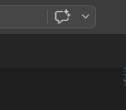

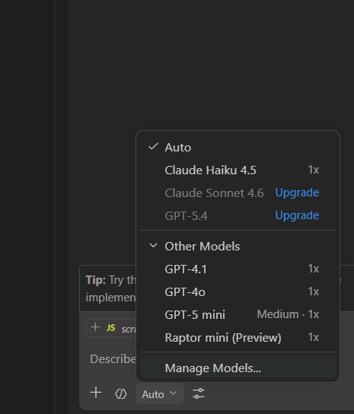

Different modes
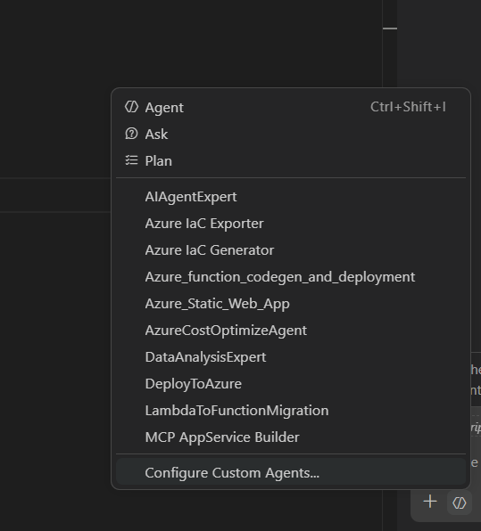

✅ How to Add Multiple Files in Plan Mode

🔹 Method 1: Using “+” Button (Recommended)
In your Copilot Chat panel (bottom right):
- Click the ➕ (plus icon)
- You will see options like:
  - Files
  - Folder
  - Selection
- Choose:
👉 Files
- Select multiple files:
  - index.html
  - script.js
  - style.css

Prompts.txt
[plan mode]:
This is a static html project called Bucks2Bar. We need a UI library for styling and we need income and expense inputs for months jan - dec. The UI should be split into 2 tabs ("Data" and "Chart"), the chart tab plots a bar chart of the income and expenses from the inputs in the Data tab. We will need a suitable chart library to render this chart.

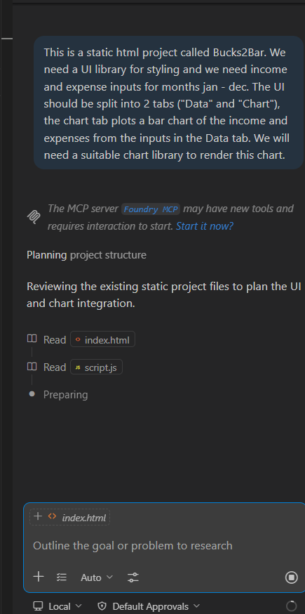

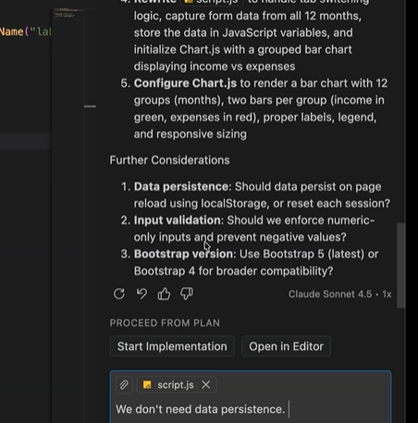

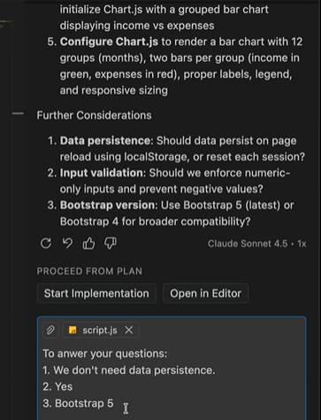
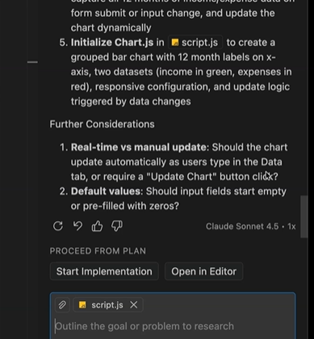

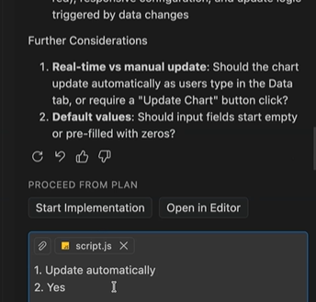

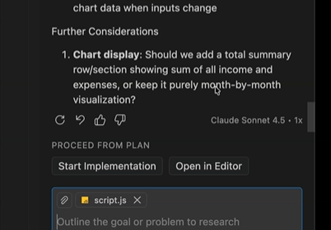

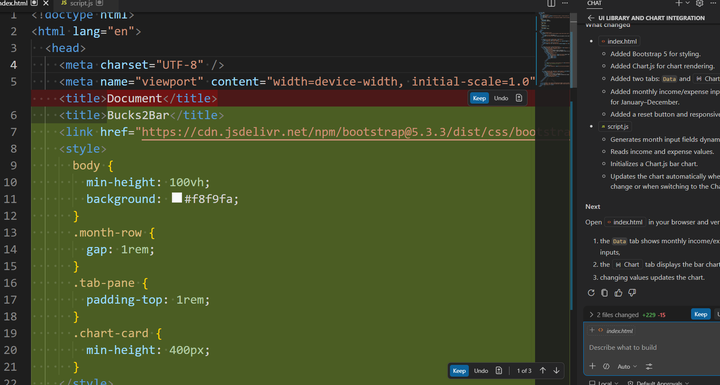

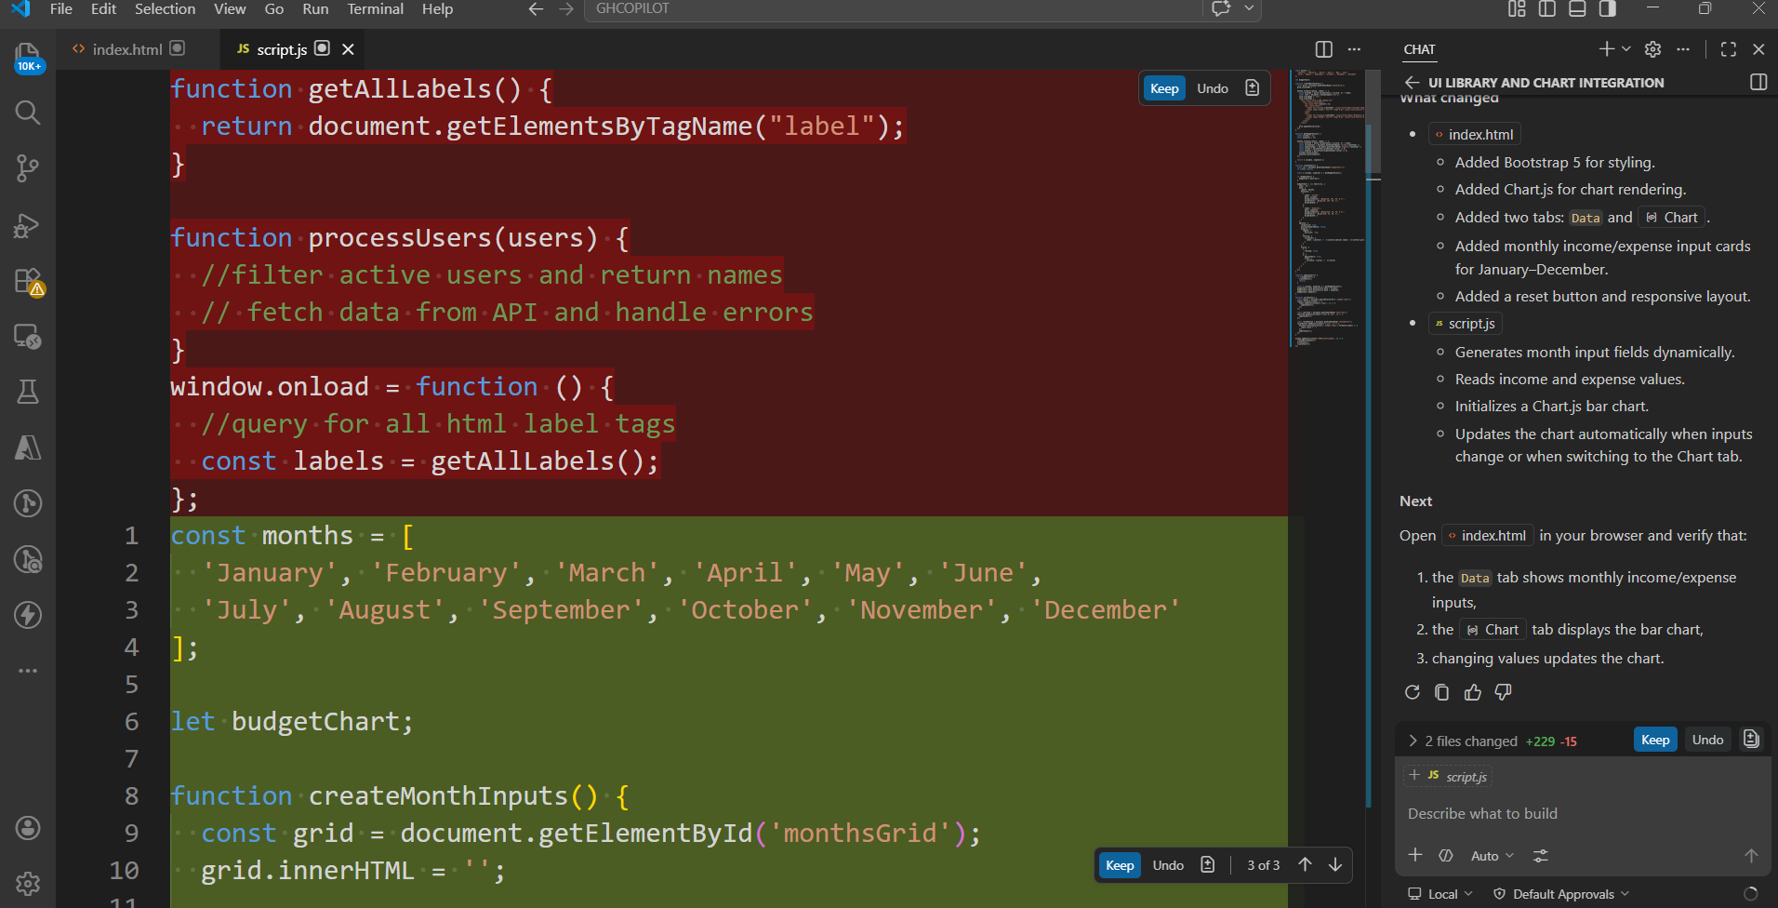
[plan mode]:
To asnwer your questions:
1. We don't need data persistence.
2. Yes
3. Bootstrap 5

[plan mode]:
1. Update automatically
2. Yes

[agent mode]:
Start implementation

Implement the Download chart feature
Restore Checkoint

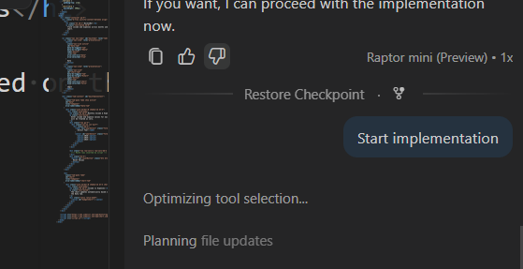

New chat Context

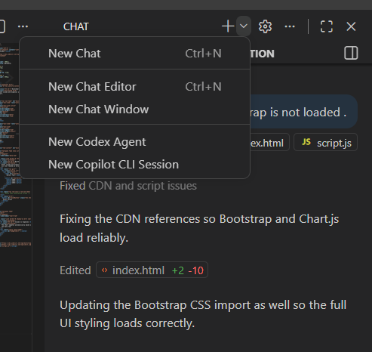

Goto index.html
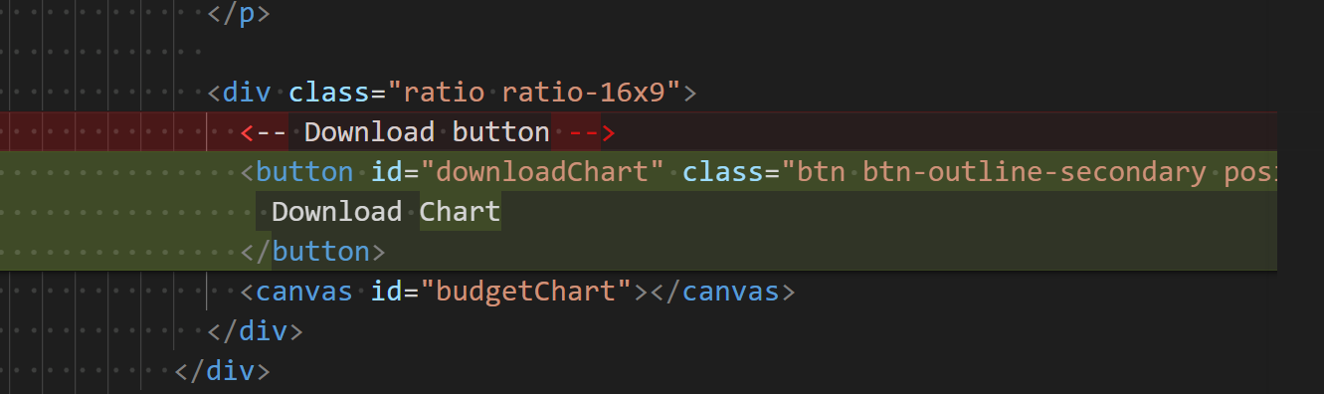

Inline Suggestion
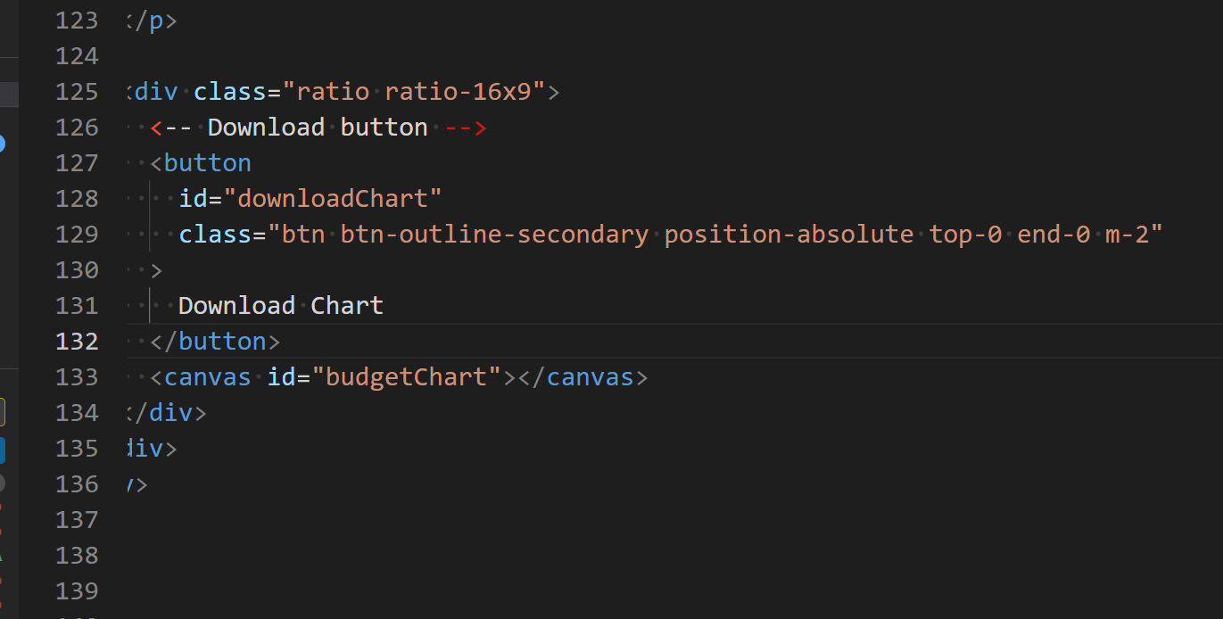

Build out the download chart as png functionality in the script.js file

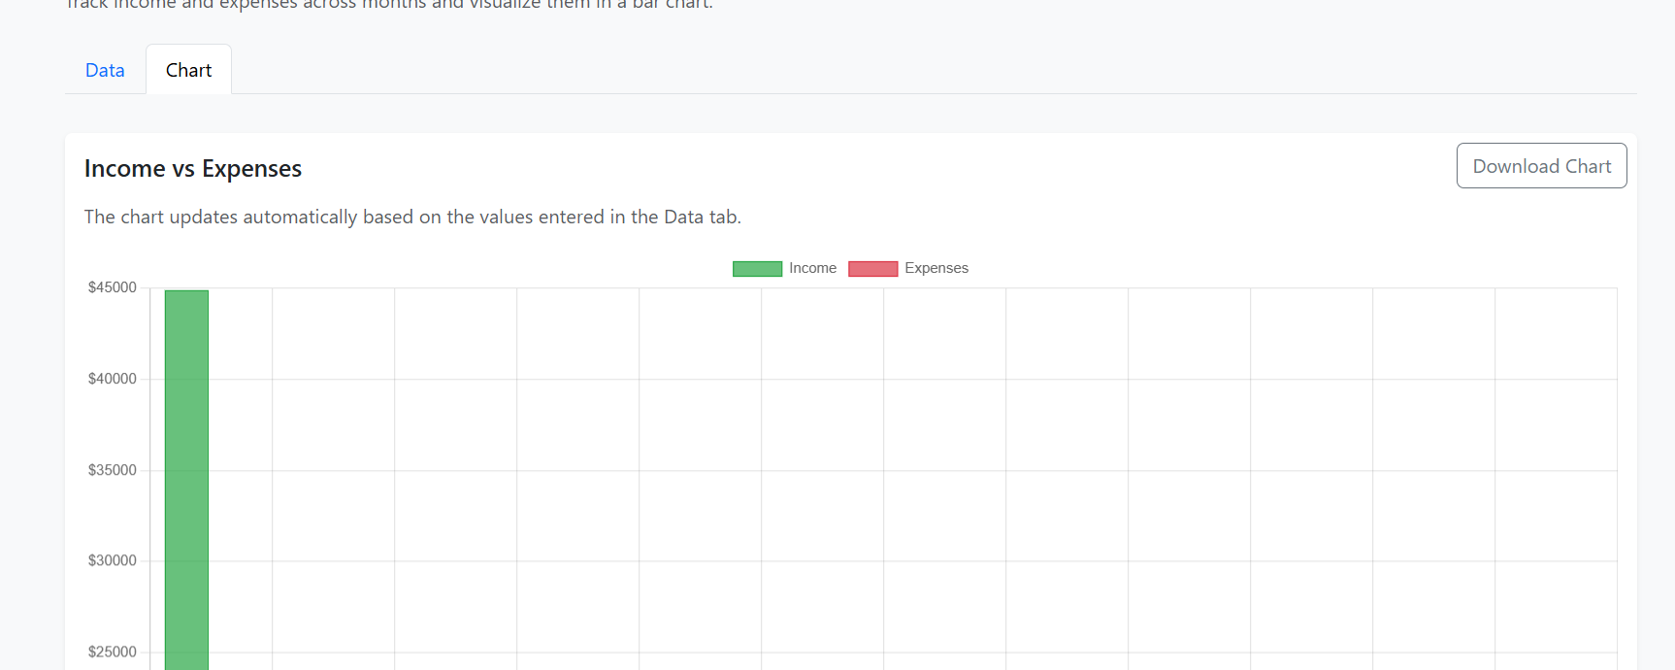

GitHub Copilot Agent Instructions

Create an agent for a static HTML project called Bucks2Bar.

The agent should:
- Handle income and expense inputs for months Jan to Dec
- Manage UI with two tabs: Data and Chart
- Update chart dynamically based on inputs
- Use a UI library for styling
- Support resetting inputs and downloading chart as PNG

The agent should assist in code generation, refactoring, and feature enhancement.

[agent mode]:
Above the data and chart tabs in #file:index.html, render a username input which must contain at least 1 uppercase letter, 1 number, and 1 special character and must be at least 5 characters long. Underneath this input, render a submit button.

